Delete discount coloum

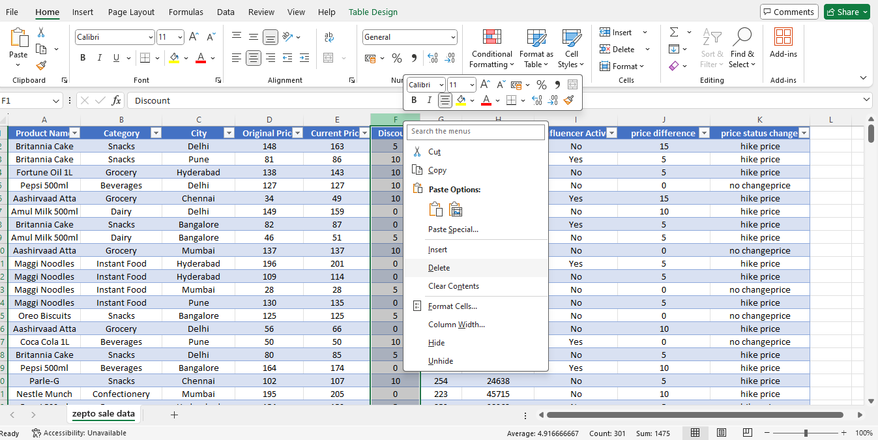Reason – there is no discount ( price hike & no change